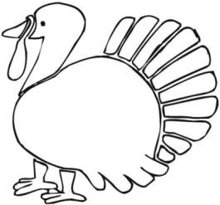

$150 per team.
3 games minimum.
16 teams, maximum.
Turkey shoot.
Includes two meals.
Coffee/tea/hot chocolate.
Contact: Tony, antstonetown@gmail.com Convener: Win, wparnall@gmail.com Deadline for registration is October 1, 2025
Team Name: | Contact Person:
Contact E-mail: | Contact Phone #:
Player one: | Player two:
Coach:
Special dietary requirements or food allergies. Please state below.

